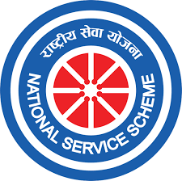
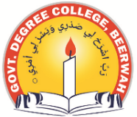
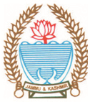
Phone: 01951275276 Fax: 01951275277
Office of the Principal
GOVERNMENT DEGREE COLLEGE BEERWAH, KASHMIR
http://www.gdcbeerwah.edu.in, Email: gdcbeerwah@gmail.com
Date: 18/11/23

Notice regarding NSS Enrollment for the Session 2023-24

Students desirous of joining National Service Scheme (NSS) for the academic year 2023-24 are hereby informed that the enrolment for the same is open from 18th November 2023 to 30th November 2023. For Enrolment students may visit Political Science Dept. and get registered themselves as volunteers. Our college has an enrollment capacity of 200 students per year. Hence enrollment will be on first cum first basis, come and join us in making this world a better to live.

Dr. Firdous Ahmad Dar
NSS Program Officer
Sd/

