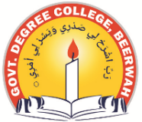
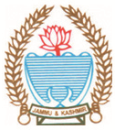
Phone: 01951275276 Fax: 01951275277
Office of the Political Science Department
GOVERNMENT DEGREE COLLEGE BEERWAH, KASHMIR
http://www.gdcbeerwah.edu.in, Email: gdcbeerwah@gmail.com

Notification for Tutorials/ Internals
This is for the information of all the regular batch-2021 and backlog batches of 2016-2020 of political science that their internals/tutorials shall be conducted by (29-30/04/2024) in the political Science Dept. The Vivo shall start at 10:30 am sharp. Any failure on your part will be marked as absent in the final reward list so be on time.
Students are instructed to cover the following topics.
1. Organization: Meaning, Nature & Scope
2. Span of Control & Unity of Command
2. Leadership
2. Department: Line, Staff & Auxiliary Agencies

HOD
Political Science

