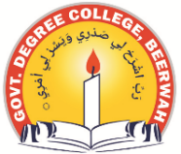
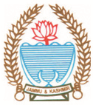
Phone: 01951275276 Fax: 01951275277
Office of the Political Science Department
GOVERNMENT DEGREE COLLEGE BEERWAH, KASHMIR
http://www.gdcbeerwah.edu.in, Email: gdcbeerwah@gmail.com

Notification for Tutorials/ Internals
In view of your final semester examination scheduled to be conducted w,e,f, 17th of October 2023 wherein the departments have been instructed to submit internal awards by 20th of September to 1st of Oct., 2023 . This is for the information of the all the regular batch-2020 and backlog batches of 2016-2019 of political science that their internals/tutorials shall be conducted by Tomorrow (22/09/2023) in the political Science Dept. The Vivo shall start at 10:30 am sharp. Any failure on your part will be marked as absent in the final reward list so be on time.
Students are instructed to cover the following topics for tomorrows written test.
2.1 Accession and Division of the Jammu & Kashmir State
2.2 Organs of Government: State Legislature, Executive & Judiciary
2.3 Local Self-Government in Jammu & Kashmir
2.4 Land Reforms in Jammu and Kashmir

HOD
Political Science

