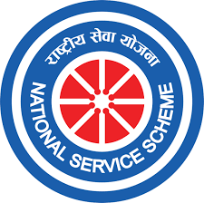
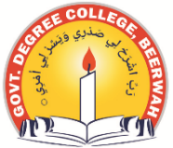
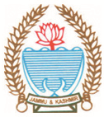
Phone: 01951275276 Fax: 01951275277
Office of the NSS Programme Officer
GOVERNMENT DEGREE COLLEGE BEERWAH, KASHMIR
http://www.gdcbeerwah.edu.in, Email: gdcbeerwah@gmail.com
No:_______________ Date: 26/07/23

Report of Cleanliness-Cum Awareness Activity
On July 26, 2023, the NSS unit of our college took an important step towards creating awareness about the drug menace prevalent in Kashmir society. During the event, Dr. Firdous Ahmad Dar shared some eye-opening statistics about the drug problem in Kashmir society. He highlighted the gravity of the situation and emphasized the urgency of addressing this issue. With a focus on preventive measures, he discussed various ways in which our society can steer clear of the drug menace. The emphasis was on adopting a collective approach to combat this problem, with the involvement of all members of society.
To engage and empower the students and NSS volunteers, Dr. Firdous Ahmad Dar inspired them to play a positive role in building a drug-free society. He provided them with valuable guidance on how they can make a difference and become agents of change in their communities.
Following the awareness session, the entire team embarked on a cleanliness drive across the college campus. Together, they diligently collected all forms of trash, including plastic bottles, litter, and other discarded materials that had been strewn on the ground. Taking responsibility for the environment, they made sure to dispose of the collected waste properly in the designated dustbins placed around the campus.
This event was a significant step towards fostering a sense of responsibility and commitment to both our society's well-being and the environment. The NSS unit's efforts not only contributed to a cleaner and healthier campus but also acted as a catalyst for building a stronger, drug-free community in Kashmir. The students and NSS volunteers left the event with a renewed determination to make a positive impact and create a better future for all.
