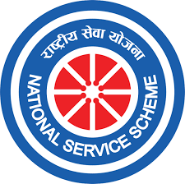
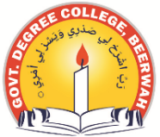
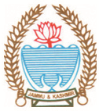
Phone: 01951275276 Fax: 01951275277
Office of the NSS Programme Officer
GOVERNMENT DEGREE COLLEGE BEERWAH, KASHMIR
http://www.gdcbeerwah.edu.in, Email: gdcbeerwah@gmail.com
No:_______________ Date: 02/08/23
Report of Punch Pran Pledge
On August 1st and 2nd, 2023, the NSS unit of GDC Beerwah organized a series of gatherings, both within classrooms and in the college ground. During these gatherings, a joint pledge was undertaken by NSS volunteers and students, united in their commitment to realizing the Punch Pran goals, as articulated by Prime Minister Narendra Modi on the occasion of India's 75th year of independence. This collective endeavor aims to work towards comprehensive development in the forthcoming 25 years.
Dr. Firdous Ahmad Dar, the NSS Programme Officer, eloquently presented these objectives to the assembled students and esteemed faculty members. Subsequently, the same goals were reiterated by the attendees. Dr. Dar emphasized the imperative for our nation to concentrate on the following five determinations:
- Envisioning a Developed India
- Eradicating Vestiges of Colonial Mindset
- Celebrating and Nurturing Our Legacy
- Harnessing the Power of Unity
- Executing Civic Duties with Unwavering Integrity
This profound commitment echoes the resolute spirit of India's citizens, dedicated to shaping a progressive and harmonious future.
