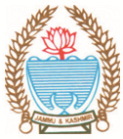
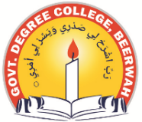
GOVERNMENT DEGREE COLLEGE BEERWAH, KASHMIR
http://www.gdcbeerwah.edu.in, Email: gdcbeerwah@gmail.com

No:_______________ Date: 18/09/23
-----------------------------------------------------------------------------------------------------------
Report on public library visit
The Debates and Seminar Committee in collaboration with library of the college organized a visit to public library having dedicated section to Mahtma Gandhi on 18-09-2023. The event was participated by 25 students along with librarian and Convener, D&S committee of the college. The purpose of the event was to aware the students about the thoughts of the M.K. Gandhi and their contribution to the nation.

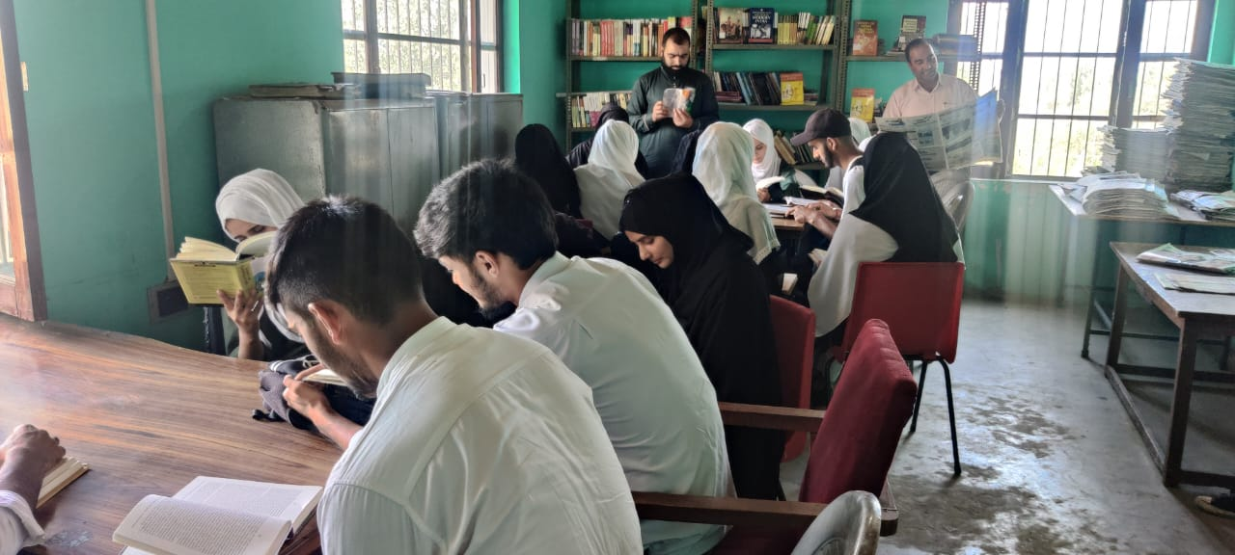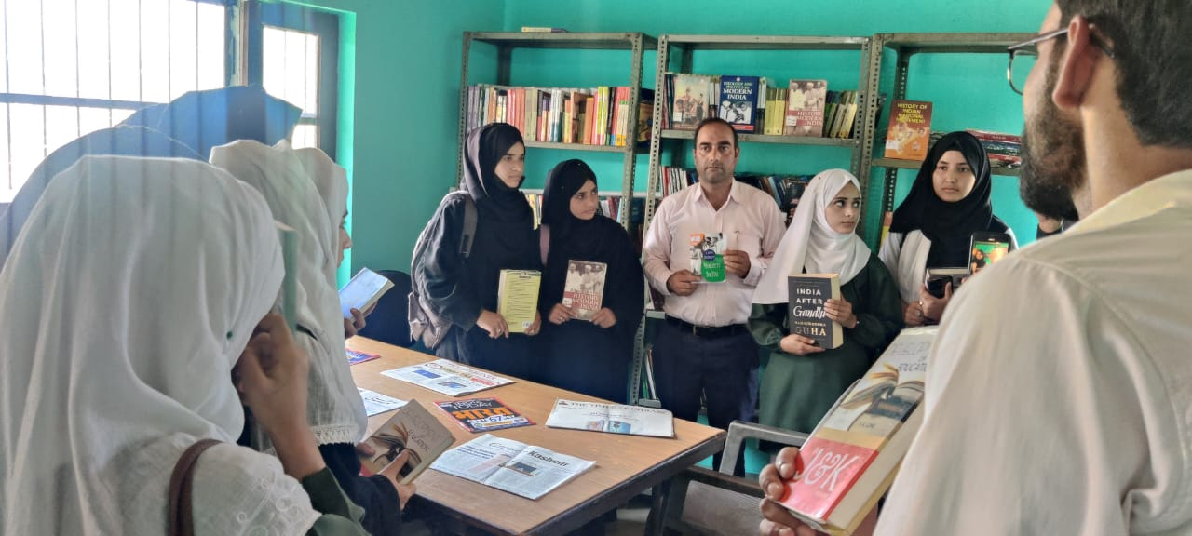
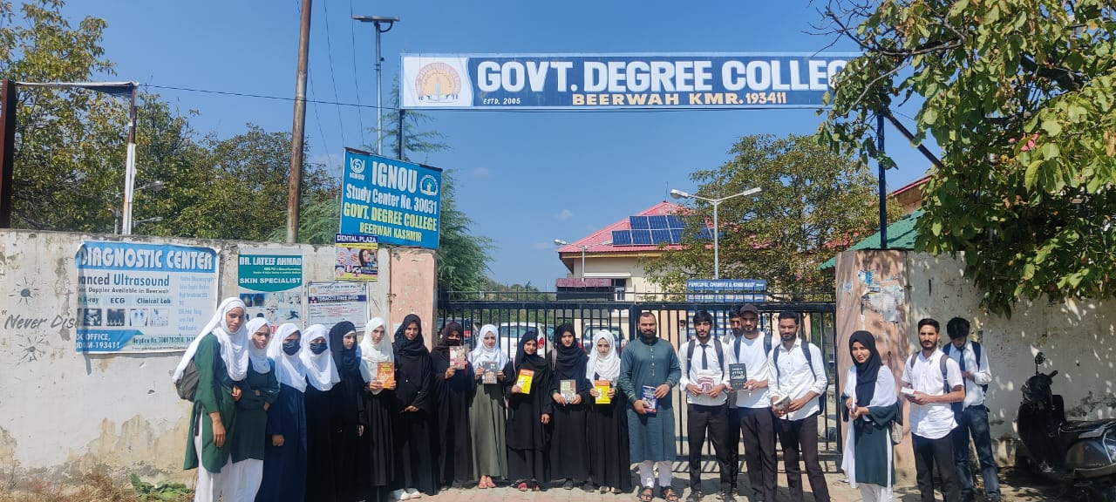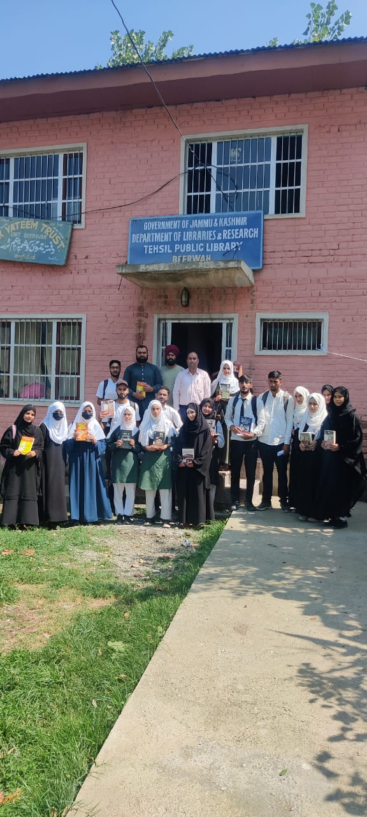
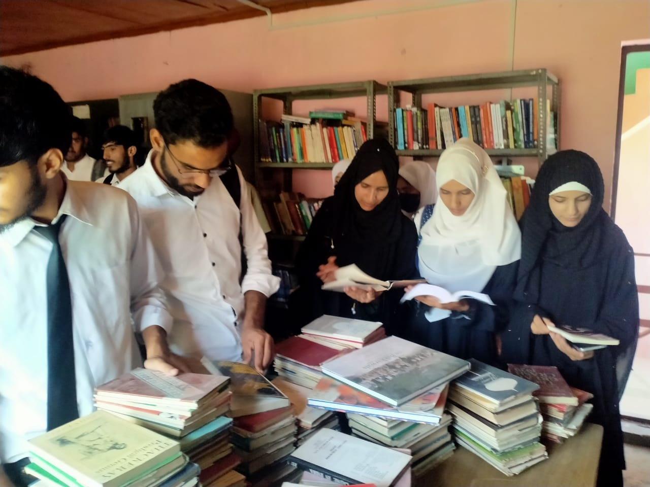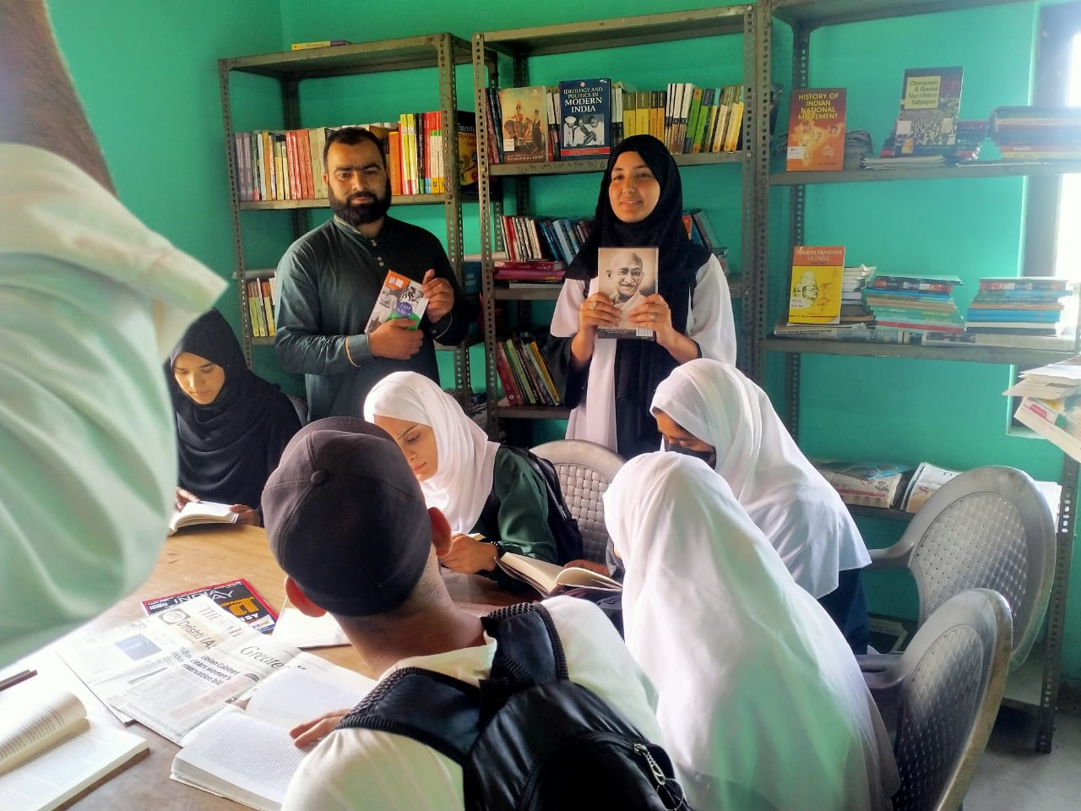

Convener
D&SC Principal

