



OFFICE OF THE PRINCIPAL

GOVT. DEGREE COLLEGE Beerwah, Kashmir

NAAC ACCREDITED GRADE “B”

**Fax: 01951275277, Phone: 01951275276, *Email:***[***gdcbeerwah@gmail.com***](mailto:gdcbeerwah@gmail.com)

**Botanical Tour Report**

The Department of Botany organized a tour for BSc 4th and 2nd semester students on 08-06-2024. In this tour, 60 students having botany subject along with the faculty members of the department & supporting staff participated. The students were taken to the Kokernag-Daksum Belt for botanical study & collection. The students were apprised of the local vegetation, forest cover & other medicinal plants of the area. In this event, the students collected plant specimens in order to prepare the herbarium. The light refreshment provided by the college was also served among the participating students.

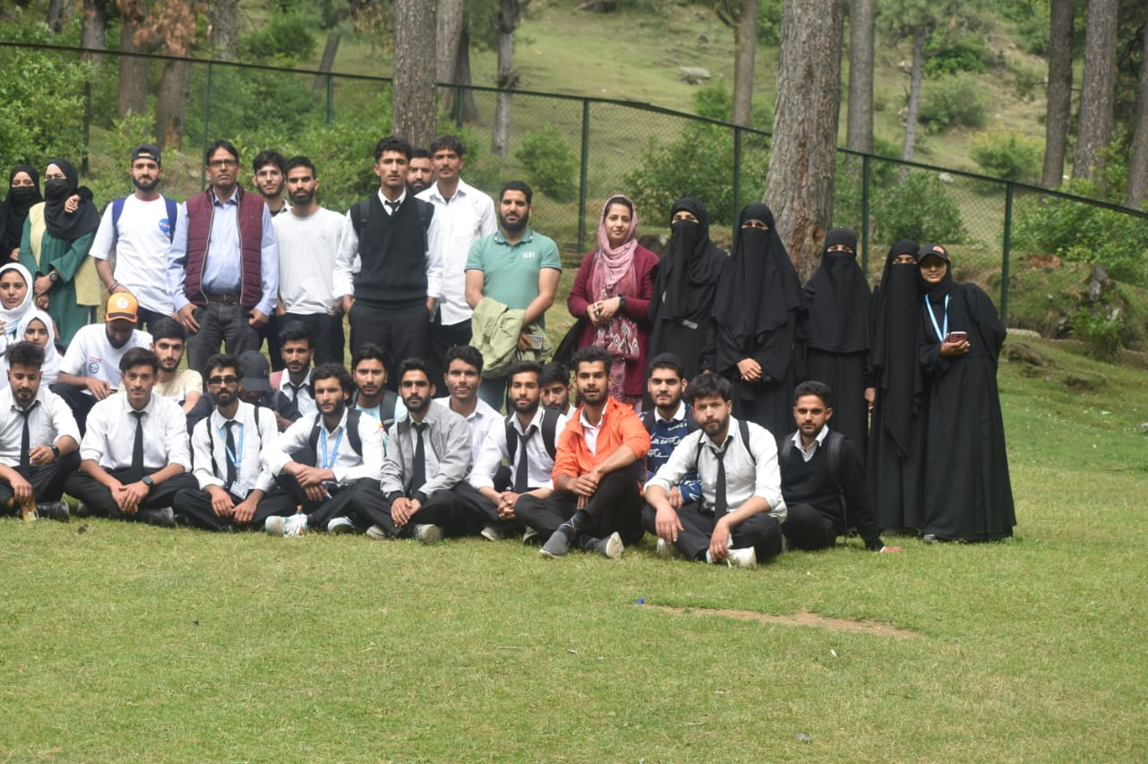

Dr Javeed Iqbal Wagay

Head

Department of Botany

GDC BEERWAH

Date 08-06-2024