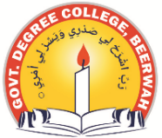
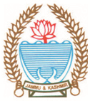
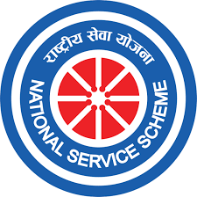
Phone: 01951275276 Fax: 01951275277
Office of the NSS Programme Officer
GOVERNMENT DEGREE COLLEGE BEERWAH, KASHMIR
http://www.gdcbeerwah.edu.in, Email: gdcbeerwah@gmail.com

No:_______________ Date: 05/03/24
------------------------------------------------------------------------------------------------------------
Door to Door SVEEP Awareness Campaign
On March 5, 2024, the Electoral Literacy Club and NSS units of the college joined hands to conduct a door-to-door voter awareness campaign as part of SVEEEP at Check Wanihama Beerwah Budgam. Dr. Firdous, the Nodal officer, and Dr. Bashir Ahmad, the NSS Programme officer, organized the initiative, accompanied by a team of enthusiastic NSS volunteers.
During the campaign, NSS volunteers visited households to inquire about SVEEP and voter enrollment drives organized at the village level by relevant departments. They not only gathered information about unregistered voters but also raised awareness about the significance of casting their votes in the upcoming elections.
The program proved to be a resounding success, inspiring students and other participants to actively engage in the electoral process. At the end, a message of empowerment was conveyed to the youth, emphasizing the importance of their role as voters in shaping the future of the country.
