**Dr. SHABIR AHMAD SHABIR,** 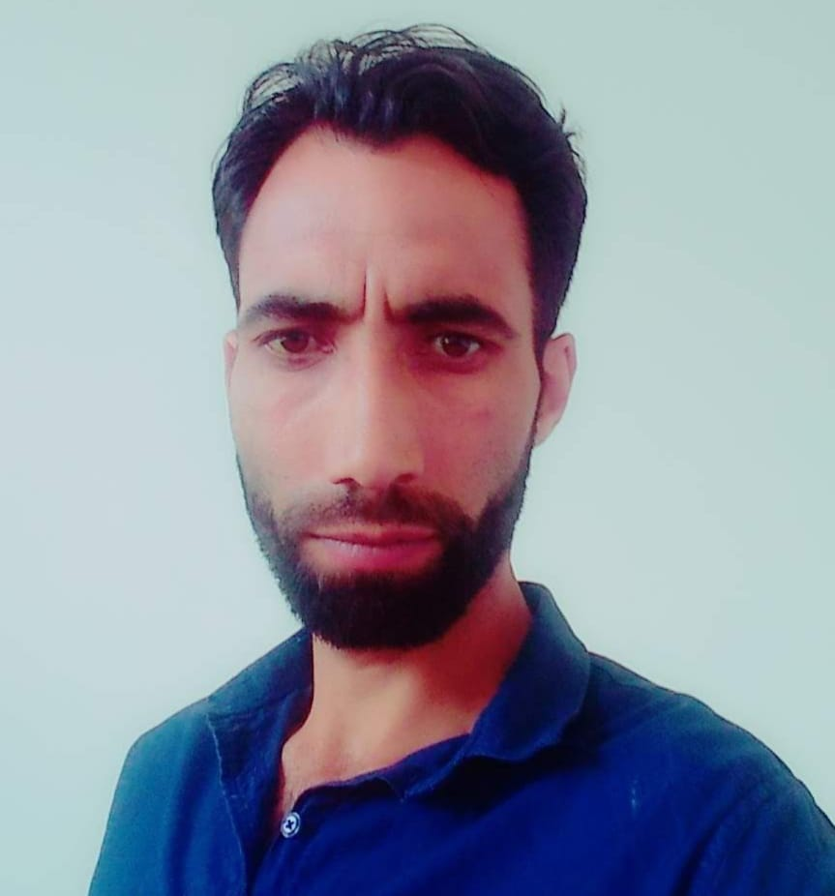

Contractual Lecturer, Department of Physics,

Govt. Degree College Beerwah, Kashmir, J&K-191134, India

**Email:**mirsabir155@gmail.com

**Phone:**+91-8825079172; +91-9596260697

**WhatsApp:**+91-8825079172

**Educational Qualification**

**2020** **Ph.D. PHYSICS**

Awadhesh Pratap Singh University Rewa, M.P., India

**2012 M.Phil. PHYSICS**

Awadhesh Pratap Singh University Rewa, M.P., India

**Academic Grade:** First Class

**2010 B.Ed (Bachelor of Education)**

**Subjects:** Theory and Principles of Education /

Psychology of Learning & Development/

Teaching of English/Teaching of Physical Science/

Population Education/

Essentials of Instructional Technology

University of Kashmir, Srinagar, India

**Academic Grade:** First Class

**2007** **M.Sc. (PHYSICS)**

**Subjects:** Quantum /Nuclear / Astrophysics /atmospheric Physics

University of Kashmir, Srinagar, India

**Academic Grade:** First Class

**2005** **B.Sc. (General Science)**

Subjects: English/Chemistry/Physics/Mathematics

University of Kashmir, Srinagar, India

**Academic Grade:** Second Class

**2000 12th**

Subjects: English/Physics/Chemistry/Mathematics

Academic Grade: Second Class

**1998** **10th**

Subjects:English/Maths/General Science/Urdu/Social Science

Academic Grade: Second Class

**Ph.D. Thesis Title:** Effects of Solar and Interplanetary Disturbances on the Earth’s Climate.

* **Working Skills**
* Planning and execution of research work in laboratory.
* Computation and interpretation of experimental data.
* Preparation and editing of research material/manuscripts for publication in journals of national and international repute.

**Teaching Experience**

1. Teaching undergraduate B.Sc. students at Govt.Sheikh-ul-Alam Memorial Degree College Budgam, Kashmir from 10th April2013 to 28th February 2014.
2. Teaching undergraduate B.Sc. students at Govt. Degree College Tral, Kashmir from 16th May 2018 to 31th July 2019.
3. Teaching undergraduate B.Sc. students at Govt. Degree College Tral, Kashmir from 5th March 2020 to 26th December 2020.
4. Teaching undergraduate B.Sc. students at Govt. Degree College Tral, Kashmir from 14th February 2021 to 31th July 2021.
5. Teaching undergraduate B.Sc. students at Govt. Degree College Tral, Kashmir from 15th April 2022 to 26th  December 2022.
6. Teaching Higher Secondary students at Govt. HR. SEC School Tokuna Gulzarpora Pulwama, Kashmir from 6th March 2009 to 12th December 2009.
7. Teaching Higher Secondary students at Govt. HR. SEC School Panzgam Pulwama, Kashmir from March 2010 to 29th December 2010.

**Publications**

1. **Research Papers** Variation of Solar Activity parameters with cosmic Ray Intensity and comparison of solar cycle 23-24.

**Shabir Ahmad**, P.R.Singh, A.K.Saxena, C.M.Tiwari

International journal of Scientific Research, Engineering and Technology / on line ISSN: 2394-4099.

1. Solar wind plasma associated with Dst< -50 nT during solar cycle 24

P.R.Singh, **S.Ahmad**, B.Nigam, P.K.Chamadia, A.K.Saxena and C.M.Tiwari

International Journal of Physical sciences.Vol.12 (21), pp.280-285, 16 November 2017.

1. Cosmic Ray Associated with Coronal Index and Solar Flare Index during Solar cycle 22 – 23.

Prithve Raj Singh**, Shabir Ahmad**, A.C.Pandey, A.K.Saxena, C.M.Tiwari, A.P.Mishra

International Journal of Astronomy and Astrophysics, 2017, 7,162-173.

1. Heliospheric Effect on Sunspot Area During Ascending phase of Solar Cycle

Prithve Raj Singh, D.K.Pathak, **Shabir Ahmad**, A.K.Saxena, C.M.Tiwari

National journal Vindhya Bharati ISSN 0976-9968.

1. Effects of Geomagnetic Storms and their Association with Solar wind velocity during 1996-2016.

Sham singh, Kalpana Singh, Ajay Vasishth, A.C.Panday, **Shabir Ahmad** and A.P.Mishra

International journal of Scientific Research, Engineering and Technology / on line ISSN: 2394-4099.

6. Comparative Study of Odd and Even Solar Cycles.

Sarver Ahmad, Niyaz Ahmad, **Shabir Ahmad,** C.M.Tiwari, A.K.Saxena, A.P.Mishra,

G.N.Singh, K.L.Jaiswal.

International Journal of Scientific Research in Physics and Applied Science. ISSN:

2348-

3423 (online).

7. Solar plasma related to Geomagnetic Disturbance storm time during Solar Cycle 22 & 23.

P.R.Singh, **S.Ahmad**,A.K.Saxena,C.M.Tiwari and S.L. Agrawal.

Indian Journal of Radio and Space Physics Vol. 50, September2021,pp .156-162

**Papers Presented in Conferences**

1. Correlative Analysis of Cosmic Ray Intensity with Solar Activity Parameters for Solar Cycle 23 and 24.

**Shabir Ahmad**, C.M.Tiwari, A.K.Saxena

4th International Conference on Recent Trends and Advancements in Engineering and Technology (ICRTAET), Shri Mata Vaishno Devi University Katra, 3rd -4th November, 2017.

1. Effects of Cosmic Ray and Total Solar Irradiance on Earth’s Climate during Solar Cycle 24.

**Shabir Ahmad**, A.K.Saxena, C.M.Tiwari

National Seminar on National Development through Science and Technology, Indian Science Congress Association “Srinagar Chapter” University of Kashmir, 25th – 26th September, 2017.

1. Correlation of Cosmic Ray Intensity with Sunspot Number and Auroral Electro jet Index during 1986-2016.

**Shabir Ahmad**, A.K.Saxena, C.M.Tiwari

National Conference on Emerging Trends in Materials Science (NCETMS), Shri Mata Vaishno Devi University Katra, 7th -8th February , 2018

1. The Effects of Total Solar Irradiance and Solar Wind Plasma Temperature on Global Climate change.

**Shabir Ahmad**, A.K.Saxena, C.M.Tiwari

National Seminar on Climate Change and Human Health, Issues, Concerns and Opportunities, Govt. Degree College Bijbehara Kashmir, 8th -9th October, 2018.

1. Variation of Solar activity Parameters with Cosmic Ray Intensity and comparison of Solar Cycle 23-24. **ShabirAhmad**,C.M.Tiwari,A.K.Saxena USG Sponsored National Seminar on growth points in physics (GPP-2017) organized from 21st -23rd October 2017 by post graduate department of physics ,University of Kashmir.
2. Phase relationship between the Cosmic Ray Intensity and Sunspot Number during solar cycle 22-24

**Shabir Ahmad**, C.M.Tiwari, A.K.Saxena

International Conference on Recent trends in Mathematical Science and Cosmology December 17th - 18th 2016 Department of Mathematics and Computer Science Govt. Model Science College Rewa (M.P.) 486001, India

1. Variation of Solar Activity and Cosmic Ray Intensity during Solar Cycle 22-24.

**Shabir Ahmad**, P.R.Singh, C.M.Tiwari, A.K.Saxena

CONIAPS XX, 20TH International Conference of International Academy of Physical Science on Recent Advances in Physical Sciences and Future Challenges, July 14th - 16th 2017,Organized by Faculty of Science (Department of Mathematics, Physics and Chemistry ), Osmania University, Hyderabad-500007.

1. High Energy Cosmic Ray Intensity Anisotropies with Solar Activity.

**Shabir Ahmad**, P.R.Singh, A.K.Saxena, C.M.Tiwari

National Seminar on “Energy Harvesting, Storage and Recycling” held at Mahatma Gandhi Chitrakoot Gramodaya Vishwavidyalaya Chitrakoot Satna (M.P.) on 30th - 31st March, 2017

1. The study of long term modulation of Cosmic Ray Intensity in relation to Sunspot number, Total solar Irradiance and Geo magnetic index.

**Shabir Ahm**ad, A.K.Saxena, C.M.Tiwari

National Conference on recent trends in Space Science and Nano Material, organized by department of Physics A.P.S University Rewa (M.P.), 26th - 27th March, 2018

1. Two days National Workshop on Nano-Science-Opportunities and Challenges, Organized by department of Physics and department of Chemistry, Islamic University of Science and Technology, Awantipora, Jammu and Kashmir, on 4th and 5th September, 2018.

**Personal Details**

Father’s Name: Ab. Majid Mir

Mother’s Name: Haseena Banoo

Date of Birth: 25th February, 1982

Nationality: Indian

Marital Status: Married

Permanent Residence: Wasoora Pulwama, Kashmir, J&K-192301, India

**Declaration**

I hereby declare that the details stated above are true to the best of my knowledge and belief.

**Place:** Pulwama 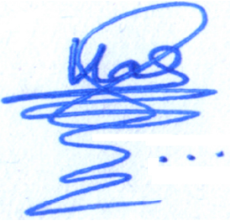

**(Dr. Shabir Ahmad Shabir)**

**Date: 1**1-12-2024